
MONTHLY SEO REPORT
HMN HOLIDAYS (https://hmnholidays.com)
Date: 15/05/2023

SUNWEST SOLUTIONS

Performance:
This report shows the performance of HMNHolidays.com in the last 28 days.
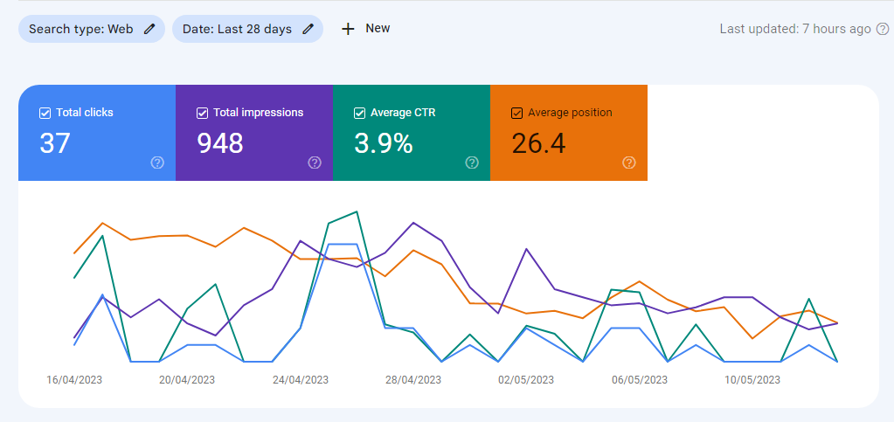
Fig 1
Fig 1 shows the performance summary of our website like total clicks, total impressions, average click through rate and average position.
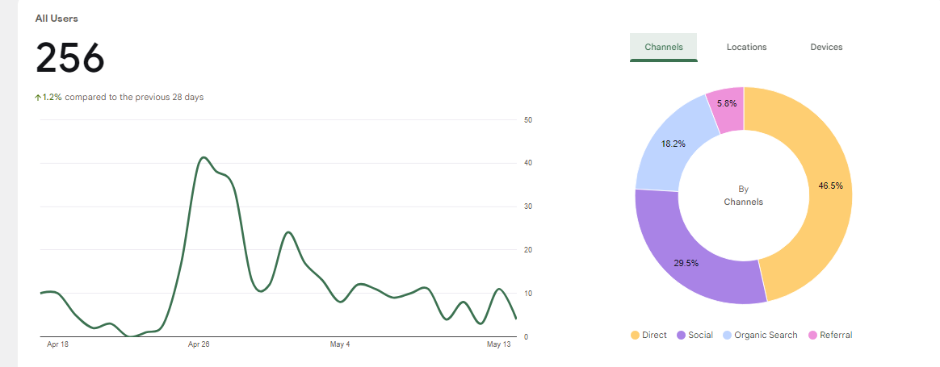
Fig 2
Fig 2 shows the total user and channels from which users have come across on our website.
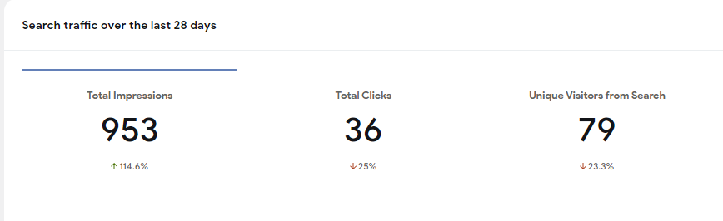
Fig 3
Fig 3 shows the website traffic of last 28 days, like total impressions (how many times our website has appeared in search result), total clicks (how many times people have clicked on our site in search results) and unique visitors.
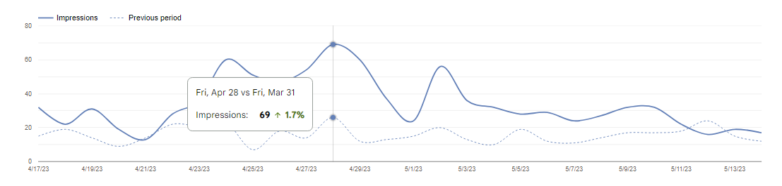
Fig 3
Fig 3 is the graphical representation of fig 2.

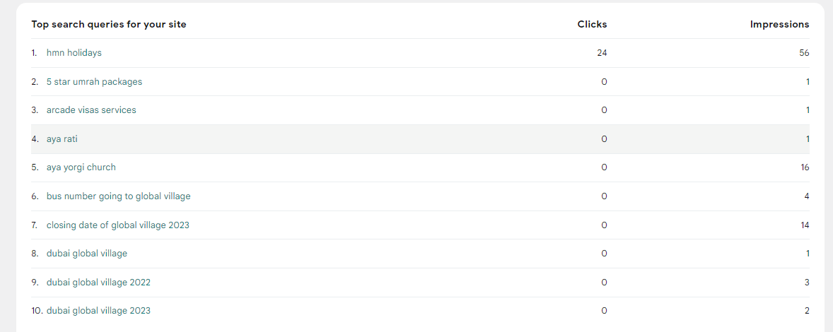
Fig 4
Fig 4 shows the top search queries for our websites in the last 28 days.

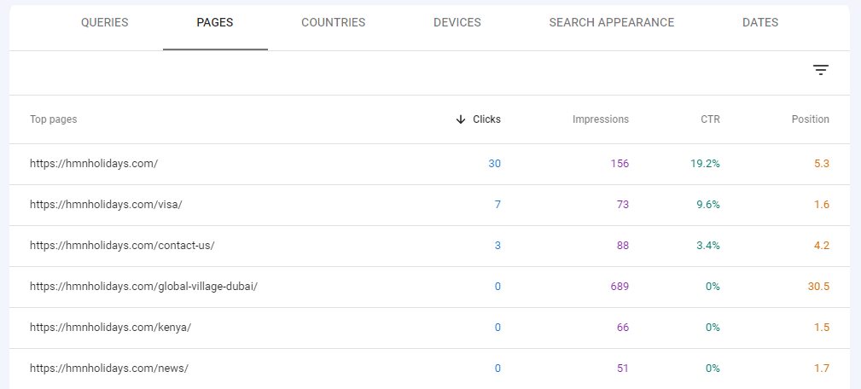
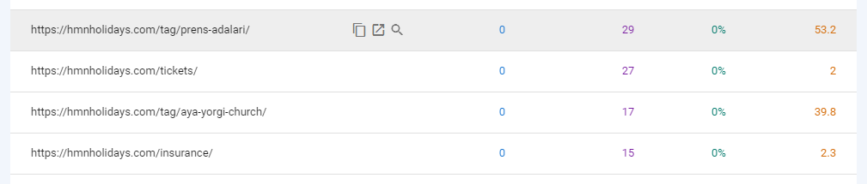
Fig 5
Fig 5 shows the top pages of our website with impression (how many times they appeared), how many times they have been clicked and their position.

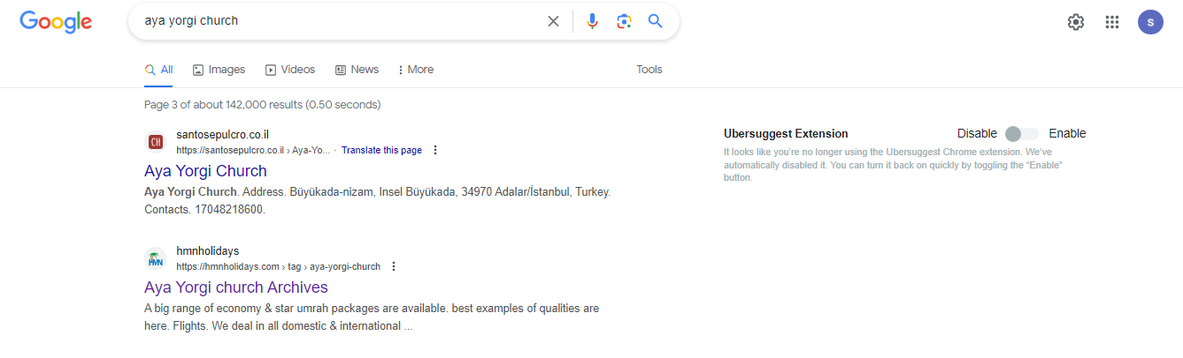
Fig 6
Fig 6 is the result of a query (aya yorgi church) on this key word our website appeared in 3 page

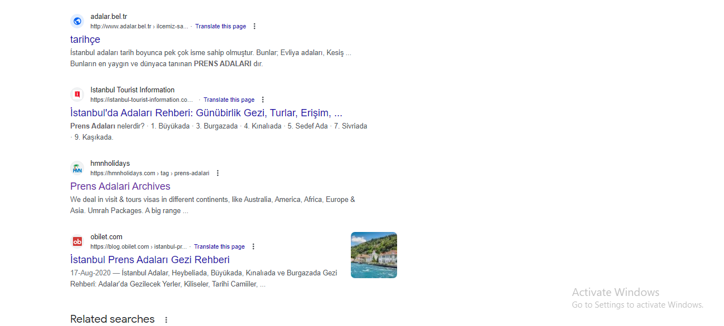
Fig 7
Fig 7 is the result for keyword prens adalari , our website appears on 3 page for this keyword.

