- Subjects Offering ( cards based design or table , what fields to show )

Make it Card base, Fields to show->(Image, title, description, category).
We need subject start and end date while adding new subject.
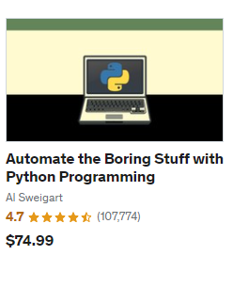
*Image is attached for design reference

- Subjects Statuses ( what could be statuses )

Status should be Active, Cancel, Pending
- Schedule Calendar for Classes:

Design should be calendar based. We need to add course duration and class timing while adding new course. And on click a complete schedule will be show.
Image is attached for reference.

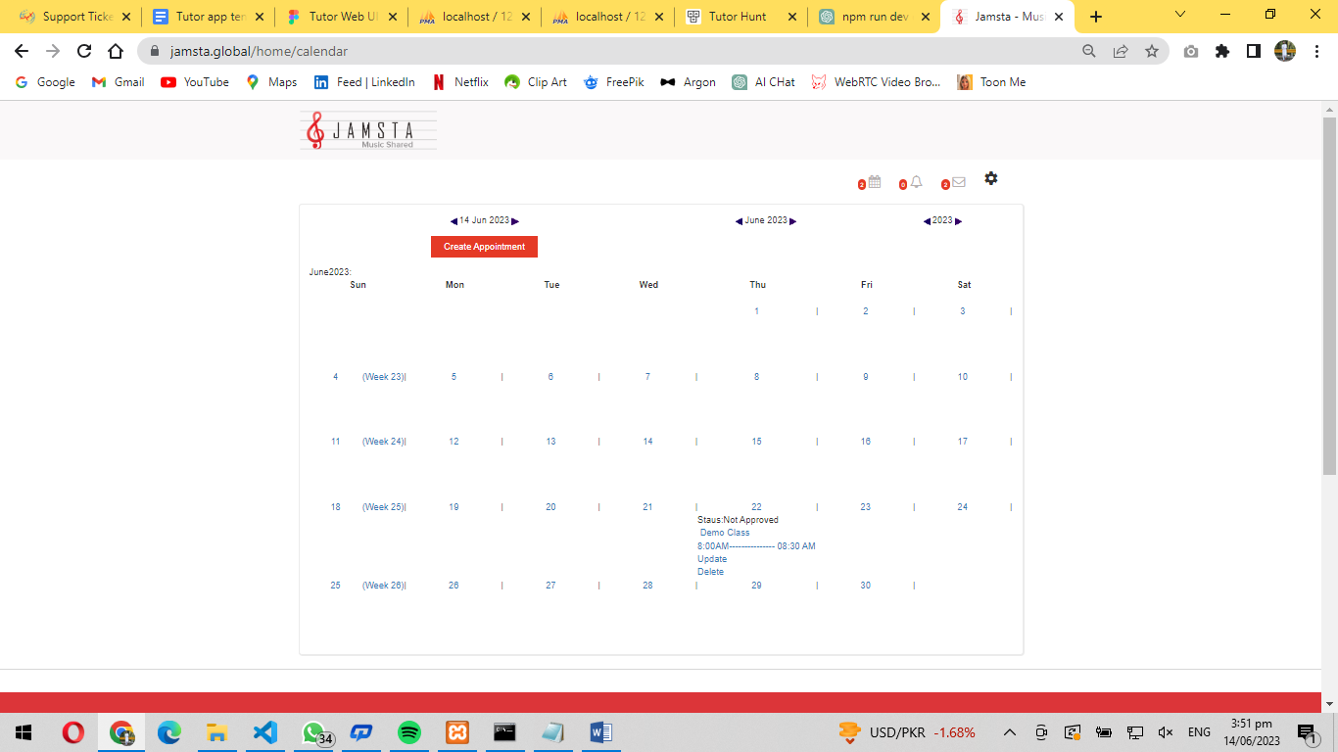

- Whiteboard and live Streaming with Registered Students to deliver Class
(desing will be from sdk? )
Screen shot is attached. Kindly create a design liked this.
