Jamsta
Dated: 10 March 2023

Header color changed to gray and fixed the overlapping of sign up form on top musician section.

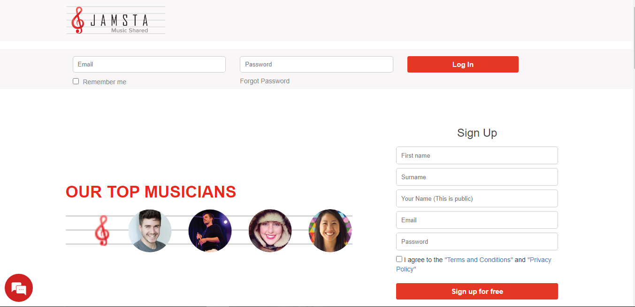

Top logo size is adjusted.

Fixed the font family to open sans and changed the color of button on hover now all home page buttons will turn black on hover. The background color of section is also changed.
Alignment of each section is now adjust.

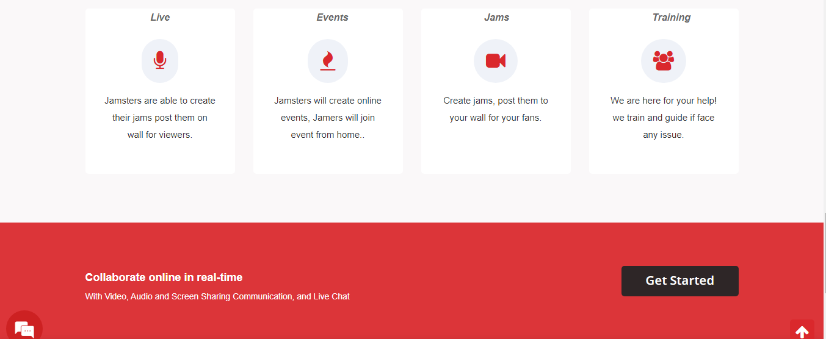


Footer background color has been changed to gray also the font family is adjust to open sans.
Background, icons and heading color is now according to logo color scheme. We user Red, Black and Grey color on front-end designing.

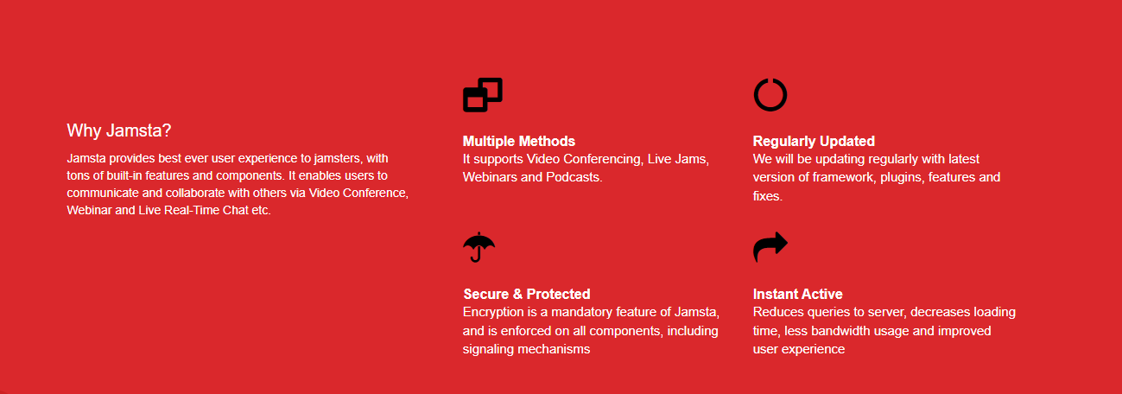

Main page side bar design is changed;

When user view his/her own wall the profile design is now changed and looks like:
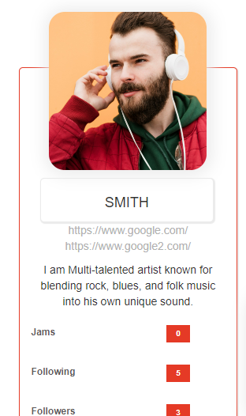
The profile picture design is changed and now it looks more attractive, The name is displaying in a box and after that all the user details are listed.
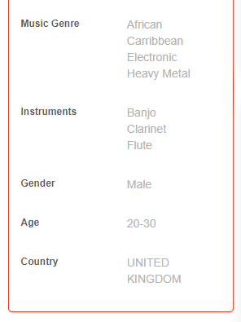

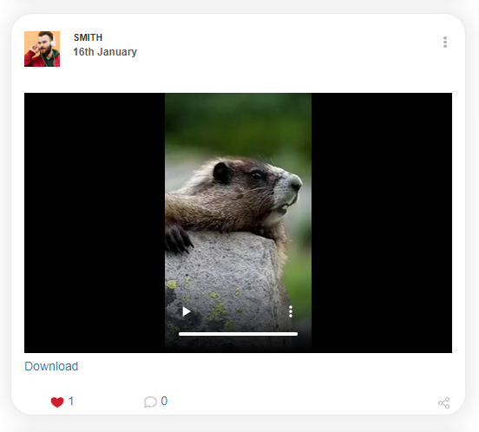

Here is the view of users wall posts, the post design is now shown as above.

